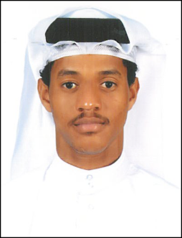

**CURRICULUM VITAE**

**ABDULLA ALSADIQ ABDULLA AHMED**

**Location**: West Riffa Kingdom of Bahrain

**Mobile**: +973 36908840

**Email** : zed64@hotmail.com

**CPR No**: 991212932

**Career Objectives:**

To pursue a challenging and growth oriented career. Willing to be a part of professionally managed team coupled with growth and individual development

**Personal information:**

Nationality : Bahraini

Date of Birth : 07-12-1999

Gender : Male

Marital Straus : Single

Languages Known : Arabic and English

**Educational Qualification :**

* Higher Secondary ( 12th )
* Certificate Success Communication and Success Leadership Series from **Toastmasters International**

**Working Experience :**

* 1 Year experience for delivery department Carriage in Bahrain

**Skills:**

* Good organization skill
* Willingness to practical learn
* Strive to succeed
* Follow standards
* Self confident and self-motive

**Declaration**

I hereby declare that all the above statements made are correct to the best of my knowledge and belief.

References will be provided upon request

**ABDULLA ALSADIQ ABDULLA AHMED**